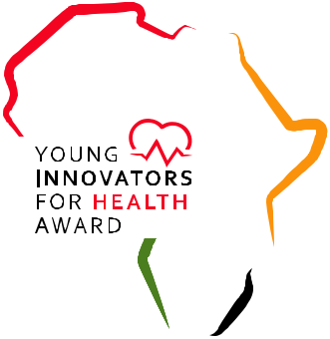
Embargoed until Tuesday, 8 December 2020 at 13:00 GMT

Speak Up Africa and IFPMA launch the “Africa Young Innovators for Health Award” to fuel innovation and help advance promising healthcare solutions
- The first edition of the “Africa Young Innovators for Health Award” aims to support entrepreneurs develop their pioneering solutions to support, equip, protect and train healthcare workers.
- Three award winners will receive funding of up to $40,000 to bring their healthcare innovation to life, and benefit from a business mentorship programme and support to protect their Intellectual Property assets.
Dakar, Geneva, 8 December 2020 - The International Federation of Pharmaceutical Manufacturers & Associations (IFPMA) and Speak Up Africa launch the first edition of the “Africa Young Innovators for Health Award” at the Galien Pre-Forum Africa session focused on Youth Leadership.
Prof. Awa Marie Coll-Seck, Minister of State and President of the Scientific Committee of Forum Galien Africa, who is also a Jury Member for the Award and Speaker at the launch event says “The COVID-19 pandemic has shown us more than ever how healthcare professionals and social workers are on the front line in responding to major health challenges. This multisectoral and community response contributes to building a strong and resilient health system. However, despite the increased investments in human resources and the many innovative financial mechanisms put in place across the continent, the work of these professionals and the health systems as a whole have been severely put to the test. We must support them.”
The “Africa Young Innovators for Health Award” is an investment in the human capital of Africa’s promising young entrepreneurs. “Young people across the continent are already driving forward innovation in life-saving technologies to respond to the COVID-19 health challenge and this Award will support them further. The youth are key to unleashing the human potential within the continent” explains Dr. Matshidiso Moeti, WHO Regional Director for Africa and Jury Member. This Award provides financial and in-kind support to three winners so they can advance their healthcare solutions and develop their great potential as enablers of change.
Applicants must be between 18 and 35, a resident or national of an African country, and show that their innovation is scalable, measurable, has a sustainable and positive impact on healthcare workers, and is commercially viable. Details of the award, including eligibility is available at www.africayounginnovatorsforhealth.org. Applications will be open from 11 January 2021 until 31 March 2021.
The “Africa Young Innovators for Health Award” is supported by AMREF Health Africa, BroadReach, Ecobank Academy, Forum Galien Africa, IntraHealth International, Microsoft 4Afrika, the RBM Partnership to End Malaria, and Social Change Factory, alongside our media partners: Africa.com and SciDev.Net.

For all press enquiries, contact:

Maelle Ba
maelle.ba@speakupafrica.org
+33 610 884 792

Morgane De Pol
m.depol@ifpma.org

Visit www.africayounginnovatorsaward.org

Follow our social media pages and join the conversation via #YoungInnovators4Health
Twitter: @IFPMA ; @SpeakUpAfrica1
Facebook: @SpeakUpAfrica

Notes to Editors

About the Partners

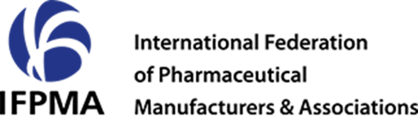

IFPMA represents research-based pharmaceutical companies and associations across the globe. Research-based pharmaceutical companies make a unique contribution to global health as innovators of lifesaving and life-changing medicines and vaccines, which improved millions of lives around the world. Based in Geneva, IFPMA has official relations with the United Nations and contributes industry expertise to help the global health community find solutions that improve global health.
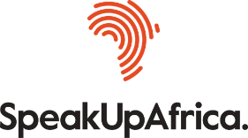

Speak Up Africa is a policy and advocacy action tank dedicated to catalysing leadership, enabling policy change, and increasing awareness for sustainable development in Africa. Through their platforms and relationships and with the help of partners, Speak Up Africa ensures that policy makers meet implementers; that solutions are showcased and that every sector – from individual citizens and civil society groups to global donors and business leaders – contributes critically to the dialogue and strives to form the blueprints for concrete action for public health and sustainable development.

